REPORT
OF
DATA ANALYTICS INTERNSHIP

Sales & Revenue Analysis, Customer Segmentation, Predictive Analytics and Data Cleaning & Reporting Automation

Submitted To
School of Computer Science and Engineering
IILM University, Greater Noida, U.P.

In partial fulfilment of the requirement of degree of
B.Tech CSE

[IILM University Logo]

By
Roll Number: _____25SCS1003003237_________________
Name: AMIT KUSHWAHA
Batch: 2026-27
Semester: ______3rd________________
Organization: Thiranex

1. CANDIDATE'S DECLARATION
I, AMIT KUSHWAHA, do hereby declare that the internship report titled "Data Analytics Internship: Sales & Revenue Analysis, Customer Segmentation, Predictive Analytics and Data Cleaning & Reporting Automation" has been completed by me to fulfil the requirement for the award of the degree of Bachelor of Technology in CSE. All the references have been quoted and I have not taken as such any material from any other source. I affirm that this report is my own and has not been submitted to any other institute for any degree/diploma requirement and further I shall be solely responsible for any kind of copyright violation in this regard.
Signature: ________________________
Student Name: AMIT KUSHWAHA
Roll No.: ________________________

2. ACKNOWLEDGEMENT
I would like to express my sincere gratitude to Thiranex for providing me with the opportunity to undertake the Data Analytics internship and gain practical exposure to real-world data analytics concepts and workflows. I am thankful for the guidance, learning resources, constructive feedback and support provided throughout the internship.
During the internship, I worked through a structured set of practical tasks covering sales and revenue dashboarding, customer segmentation, predictive analytics using historical data, and data cleaning and reporting automation. These activities helped me understand how raw business data can be transformed into actionable insights and how analytical techniques can be applied to practical business problems.
I also express my sincere gratitude to the faculty members of the School of Computer Science and Engineering, IILM University, for their academic support and guidance. Finally, I am grateful to my parents for their constant encouragement and blessings.
Signature: _______AmitKushwaha_________________
Student Name: AMIT KUSHWAHA
Roll No.: _________25SCS1003003237_______________

3. INTERNSHIP COMPLETION CERTIFICATE
Internship Completion Certificate — Thiranex
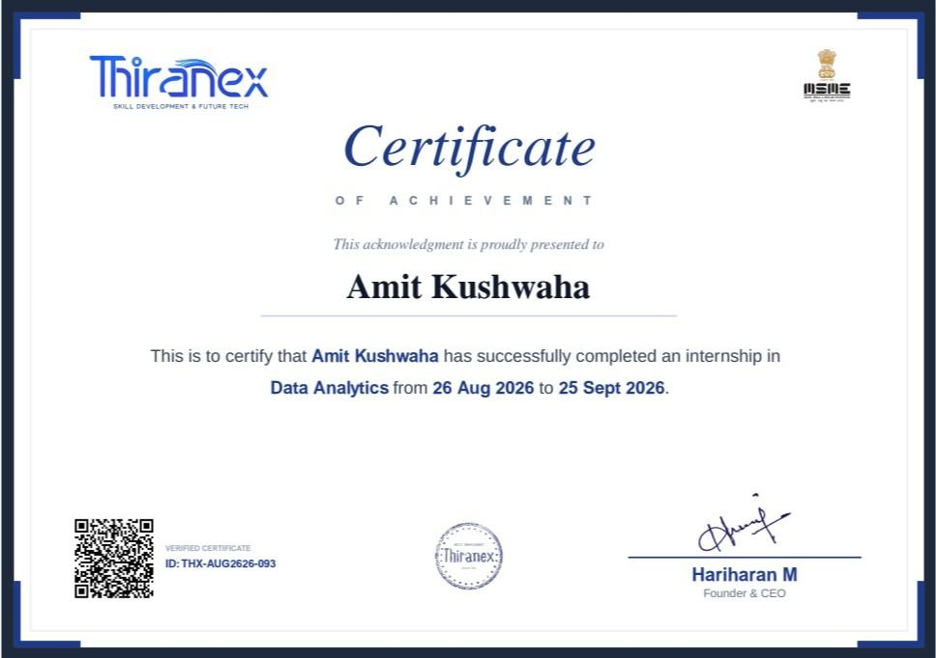
The certificate confirms that AMIT KUSHWAHA successfully completed an internship in Data Analytics from 26 August 2026 to 25 September 2026. Certificate ID: THX-AUG2626-093.

Internship Offer Letter — Thiranex
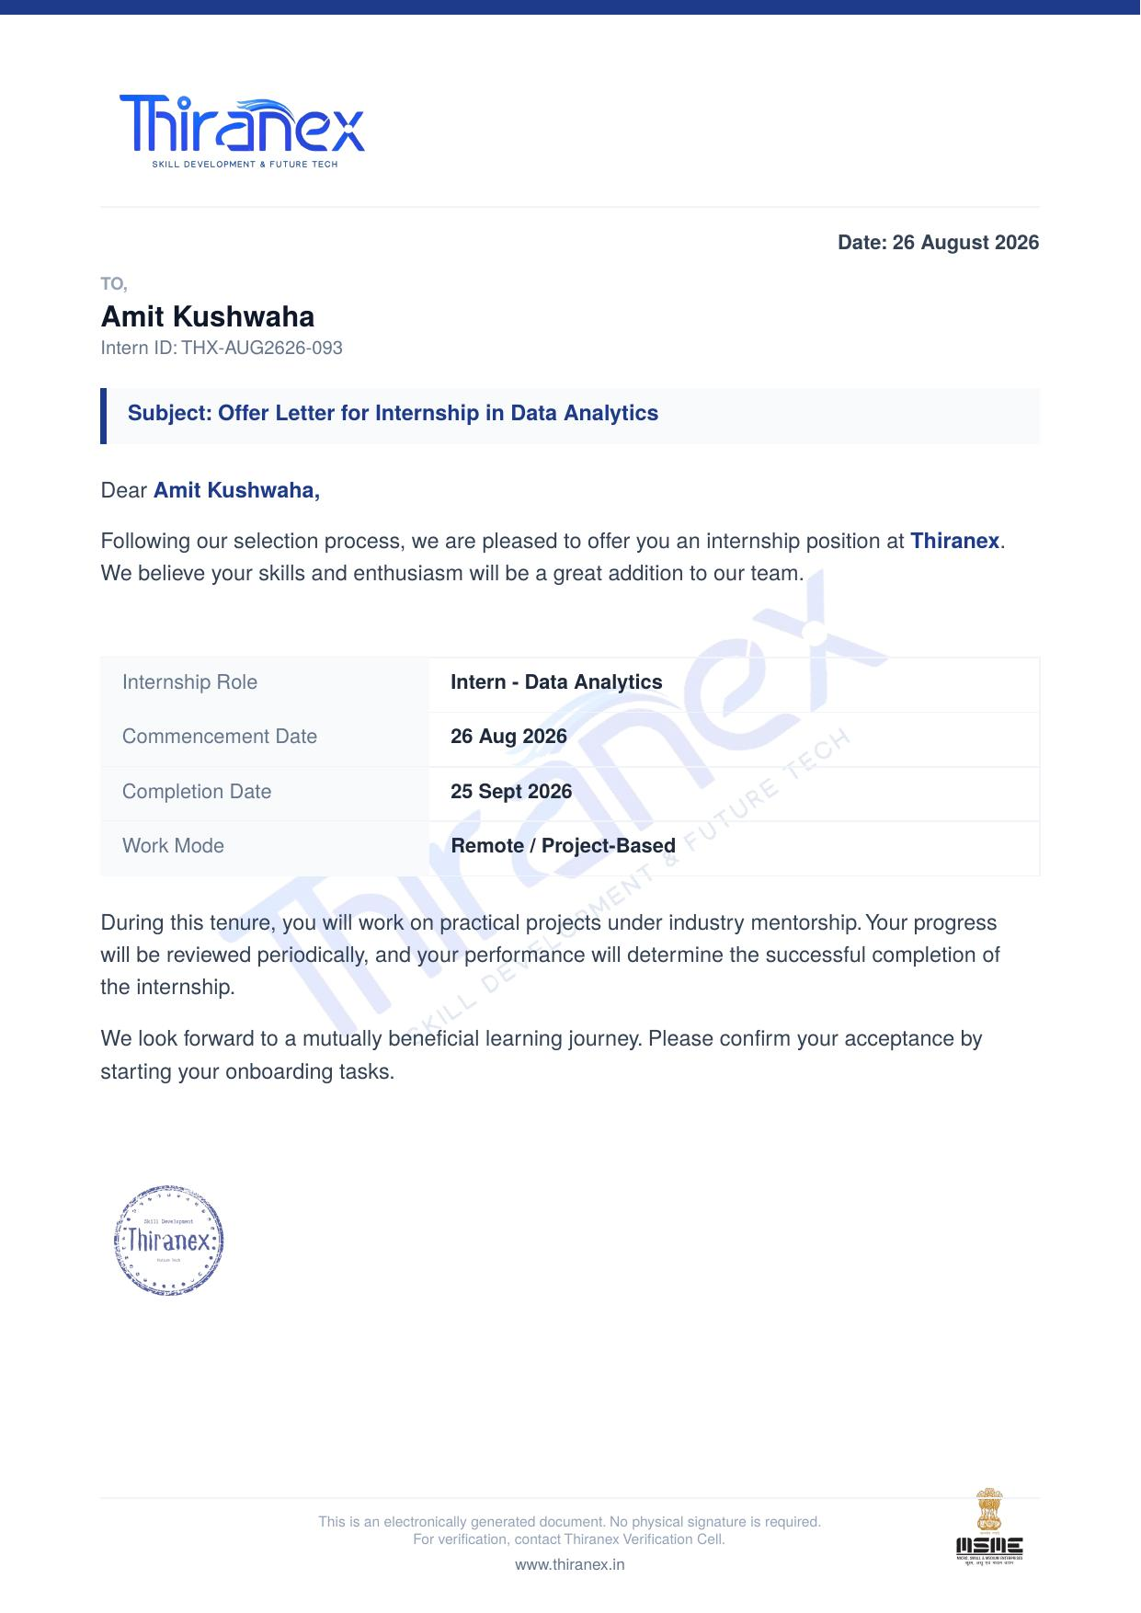
The offer letter confirms that AMIT KUSHWAHA (Intern ID: THX-AUG2626-093) was offered the position of Intern - Data Analytics at Thiranex, with a commencement date of 26 August 2026, completion date of 25 September 2026, in a Remote / Project-Based work mode.

4. PROJECT DESCRIPTION

4.1 INTRODUCTION
The Data Analytics internship at Thiranex provided practical exposure to the major stages of a business analytics workflow. The internship tasks were designed to move from dashboarding and segmentation to predictive analytics and automated data cleaning and reporting.
The work began with a Sales & Revenue Analysis Dashboard task, where the focus was on importing sales data and visualising key performance indicators such as total sales, revenue trends and top-performing products. The second task focused on Customer Segmentation, requiring clustering of customers based on behaviour and demographics to identify distinct customer groups. The third task was a Predictive Analytics project using historical data, aimed at forecasting future trends through regression or time-series models. The final task was a Data Cleaning & Reporting Automation project in which missing values, duplicates and inconsistent data were handled and automated reports were generated.
Together, these activities developed an end-to-end understanding of how business data is prepared, visualised, segmented, modelled and communicated.

4.2 ORGANIZATION PROFILE
Thiranex is presented in the internship portal as a skill development and future technology organization. The internship portal provided a structured Data Analytics learning path with practical assignments, task tutorials and completion tracking.
The Data Analytics internship consisted of four completed tasks scheduled during August and September 2026. The tasks progressively covered sales and revenue dashboarding, customer segmentation, predictive analytics using historical data, and data cleaning and reporting automation. This structure provided practical exposure to commonly used data analytics activities and encouraged the development of analytical and problem-solving skills.
The internship certificate issued by Thiranex confirms successful completion of the Data Analytics internship from 26 August 2026 to 25 September 2026.

4.3 PROBLEM STATEMENT
Business data is often spread across multiple sources, inconsistent, or difficult to interpret in raw form, making it hard for organizations to draw timely insights. At the same time, businesses require analytical methods that can summarise performance, segment customers, forecast trends and keep reporting reliable and up to date.
The internship therefore focused on solving a sequence of data analytics problems: consolidating and visualising sales data on a dashboard, segmenting customers using behavioural and demographic attributes, forecasting future trends from historical data, and automating the cleaning and reporting workflow to reduce manual effort.

4.4 PROJECT OBJECTIVES
1. To understand the practical workflow of building a business analytics dashboard.
2. To import and consolidate sales and revenue data from multiple sources.
3. To visualise key performance indicators using charts, filters and slicers.
4. To perform customer segmentation using clustering techniques.
5. To analyse purchase patterns and customer preferences.
6. To build predictive models using regression or time-series techniques.
7. To clean and preprocess historical datasets for analysis.
8. To evaluate model accuracy and visualise predictions.
9. To automate data cleaning and reporting workflows.
10. To develop analytical thinking, business insight generation and reporting skills.

4.5 SCOPE OF THE PROJECT
The scope of the internship covered the complete basic data analytics workflow from raw data preparation to dashboarding, segmentation, predictive analysis and automated reporting. It included data import and cleaning, KPI visualisation, clustering-based segmentation, regression/time-series modelling, model evaluation and generation of automated reports.
The project scope is educational and practical in nature. It demonstrates how data analytics methods can be applied to business datasets in a structured manner. The predictive analytics component allows the same workflow to be adapted to different historical datasets depending on the business context selected for implementation.
The work also provides a foundation for more advanced activities such as advanced forecasting, dashboard automation, and integration with business intelligence platforms.

4.6 TECHNOLOGIES AND TOOLS USED
Technology / Tool | Purpose
Python | Primary programming language for data analysis and predictive modelling tasks.
Pandas | Data loading, cleaning, transformation and tabular analysis.
Excel / Power BI | Dashboard creation, KPI visualisation and interactive reporting.
Matplotlib / Seaborn | Creation of data visualisations and analytical plots.
Scikit-learn | Clustering for customer segmentation and regression/time-series modelling.
Jupyter Notebook / Google Colab | Interactive environment for executing code, analysis and visualisations.

4.7 SYSTEM ARCHITECTURE
The internship workflow can be represented as a sequential data analytics pipeline. Raw sales and customer data is first imported from Excel, CSV or a database. The data is then inspected and cleaned by handling missing values, duplicates and inconsistent records. After preprocessing, KPIs are visualised on a dashboard and customers are segmented using clustering techniques. For the predictive task, historical data is used to train a regression or time-series model, which is then evaluated. Finally, cleaned data and insights are compiled into an automated report.
Raw Sales / Customer / Historical Data
↓
Data Import, Cleaning & Preprocessing
Missing Values • Duplicates • Inconsistent Data
↓
Dashboarding & KPI Visualisation
↓
Customer Segmentation (Clustering)
↓
Predictive Modelling (Regression / Time-Series)
↓
Model Evaluation & Visualisation
↓
Automated Reporting & Insights

4.8 METHODOLOGY
The methodology followed during the internship was organized into four practical tasks.
Task 1 — Sales & Revenue Analysis Dashboard: Sales and revenue data was imported from Excel, CSV or a database. Key performance indicators such as total sales, revenue trends and top-performing products were visualised using charts, filters and slicers for interactive analysis. The objective was to learn data visualisation, KPI tracking and business insight generation.
Task 2 — Customer Segmentation Project: Customers were segmented based on behaviour and demographics using clustering techniques such as those available in scikit-learn or Power BI. Purchase patterns and customer preferences were analysed, and segments and their key characteristics were visualised. The task provided experience in customer analytics, segmentation and targeted insights.
Task 3 — Predictive Analytics Using Historical Data: A predictive model was built using regression or time-series techniques to forecast future trends. Historical datasets were cleaned and preprocessed before training, and model accuracy was evaluated and predictions were visualised. This task covered predictive modelling, trend analysis and data-driven forecasting.
Task 4 — Data Cleaning & Reporting Automation: Data cleaning and reporting workflows were automated using Python, Excel or Power BI. Missing values, duplicates and inconsistent data were handled, and automated reports and visual summaries were generated. This task strengthened understanding of data preprocessing, automation and reporting efficiency.
Overall Workflow: Data Import → Data Cleaning → Dashboarding → Segmentation → Predictive Modelling → Model Evaluation → Automated Reporting.

4.9 EXPECTED OUTCOMES
1. Improved understanding of dashboard design and KPI visualisation.
2. Ability to import, consolidate and visualise sales and revenue data.
3. Practical experience in customer segmentation using clustering techniques.
4. Improved understanding of purchase patterns and customer analytics.
5. Ability to build and evaluate predictive models using regression or time-series methods.
6. Practical experience in cleaning and preprocessing historical datasets.
7. Understanding of how to automate data cleaning and reporting workflows.
8. Improved analytical thinking, business insight generation and reporting skills.

4.10 CERTIFICATES OF COMPLETION AND OTHER COMMUNICATION / TASK PROOF
The following evidence is attached to document completion of the internship and the assigned tasks. The internship portal screenshots show the four Data Analytics tasks as completed successfully: Sales & Revenue Analysis Dashboard, Customer Segmentation Project, Predictive Analytics Using Historical Data, and Data Cleaning & Reporting Automation.
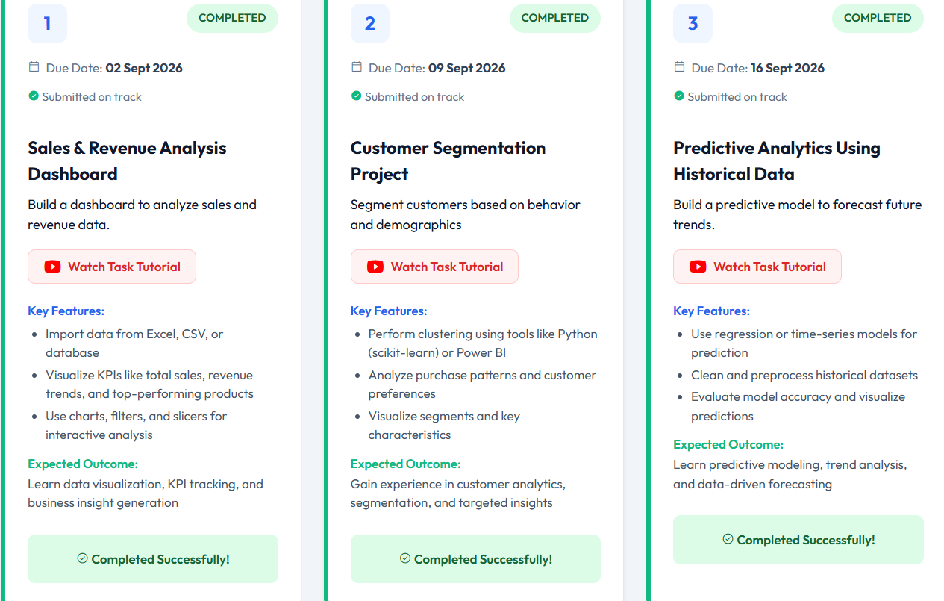
Figure 4.1: Thiranex internship task completion evidence (Tasks 1–3)
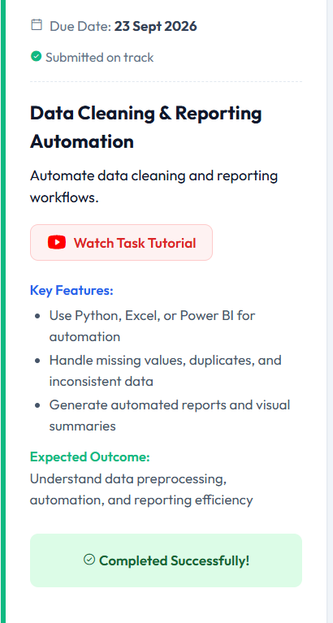
Figure 4.2: Thiranex internship task completion evidence (Task 4)

5. BIBLIOGRAPHY / REFERENCES
1. Thiranex Internship Portal, Data Analytics Internship Task Descriptions and Completion Records, accessed during the internship.
2. Pandas Documentation, Python Data Analysis Library.
3. Matplotlib Documentation, Python Plotting Library.
4. Seaborn Documentation, Statistical Data Visualization Library.
5. Scikit-learn Documentation, Machine Learning in Python.

